***Dt : 28/9/2022***

***BankTransaction : Solution***

***Balance.java***

***package test;***

***public class Balance {***

***public double bal=2000;***

***public void getBalance() {***

***System.out.println("Balance amt:"+bal);***

***}***

***}***

***CheckPinNo.java***

***package test;***

***public class CheckPinNo {***

***public boolean verify(int pinNo) {***

***return switch(pinNo) {***

***case 1111 : yield true;***

***case 2222 : yield true;***

***case 3333 : yield true;***

***default : yield false;***

***};***

***}***

***}***

***Transaction.java***

***package test;***

***public interface Transaction {***

***public static final Balance b = new Balance();***

***public abstract void process(int amt);***

***}***

***WithDraw.java***

***package test;***

***public class WithDraw implements Transaction{***

***public void process(int amt) {***

***if(amt<=b.bal) {***

***System.out.println("Amt withDrawn:"+amt);***

***b.bal = b.bal-amt;***

***b.getBalance();***

***System.out.println("Transaction Completed...");***

***}else {***

***System.out.println("Insufficient fund...");***

***}***

***}***

***}***

***Deposit.java***

***package test;***

***public class Deposit implements Transaction{***

***public void process(int amt) {***

***System.out.println("Amt deposited:"+amt);***

***b.bal=b.bal+amt;***

***b.getBalance();***

***System.out.println("Transaction completed....");***

***}***

***}***

***DemoInterface9.java(MainClass)***

***package maccess;***

***import test.*;***

***import java.util.*;***

***public class DemoInterface9 {***

***public static void main(String[] args) {***

***Scanner s = new Scanner(System.in);***

***Date d = new Date();***

***System.out.println("Data-Time of Tranaction : "+d.toString());***

***int count=0;***

***xyz:***

***while(true) {***

***System.out.println("Enter the pinNo:");***

***int pinNo = s.nextInt();***

***CheckPinNo cpn = new CheckPinNo();***

***boolean k = cpn.verify(pinNo);***

***if(k)***

***{***

***System.out.println("====Choice====");***

***System.out.println("1.WithDraw\n2.Deposit");***

***System.out.println("Enter the Choice:");***

***switch(s.nextInt())***

***{***

***case 1:***

***System.out.println("Enter the amt:");***

***int a1 = s.nextInt();***

***if(a1>0 && a1%100==0)***

***{***

***WithDraw wd = new WithDraw();***

***wd.process(a1);***

***}//end of if***

***else***

***{***

***System.out.println("Invalid amt...");***

***}***

***break xyz;//stop the loop***

***case 2:***

***System.out.println("Enter the amt:");***

***int a2 = s.nextInt();***

***if(a2>0 && a2%100==0)***

***{***

***Deposit dp = new Deposit();***

***dp.process(a2);***

***}//end of if***

***else***

***{***

***System.out.println("Invalid amt...");***

***}***

***break xyz;//stop the loop***

***default:***

***System.out.println("Invalid choice...");***

***break xyz;//stop the loop***

***}//end of switch***

***}//end of if***

***else***

***{***

***System.out.println("Invalid pinNo...");***

***count++;***

***}***

***if(count==3)***

***{***

***System.out.println("Transaction blocked...");***

***break; //will stop the while loop***

***}//end of if***

***}//end of loop***

***}***

***}***

***==============================================================***

***\*imp***

***Generalization process using Interfaces:***

***=>we can also perform Generalization process using Interfaces.***

***=>In Generalization process using interfaces,one object created***

***holding all the members of Interface and only Overriding members***

***from the Imple_Class.***

***syntax:***

***ITest ob = (ITest)new IClass();***

***Note:***

***=>we cannot perform Specialization process using Interfaces.***

***diagram:***

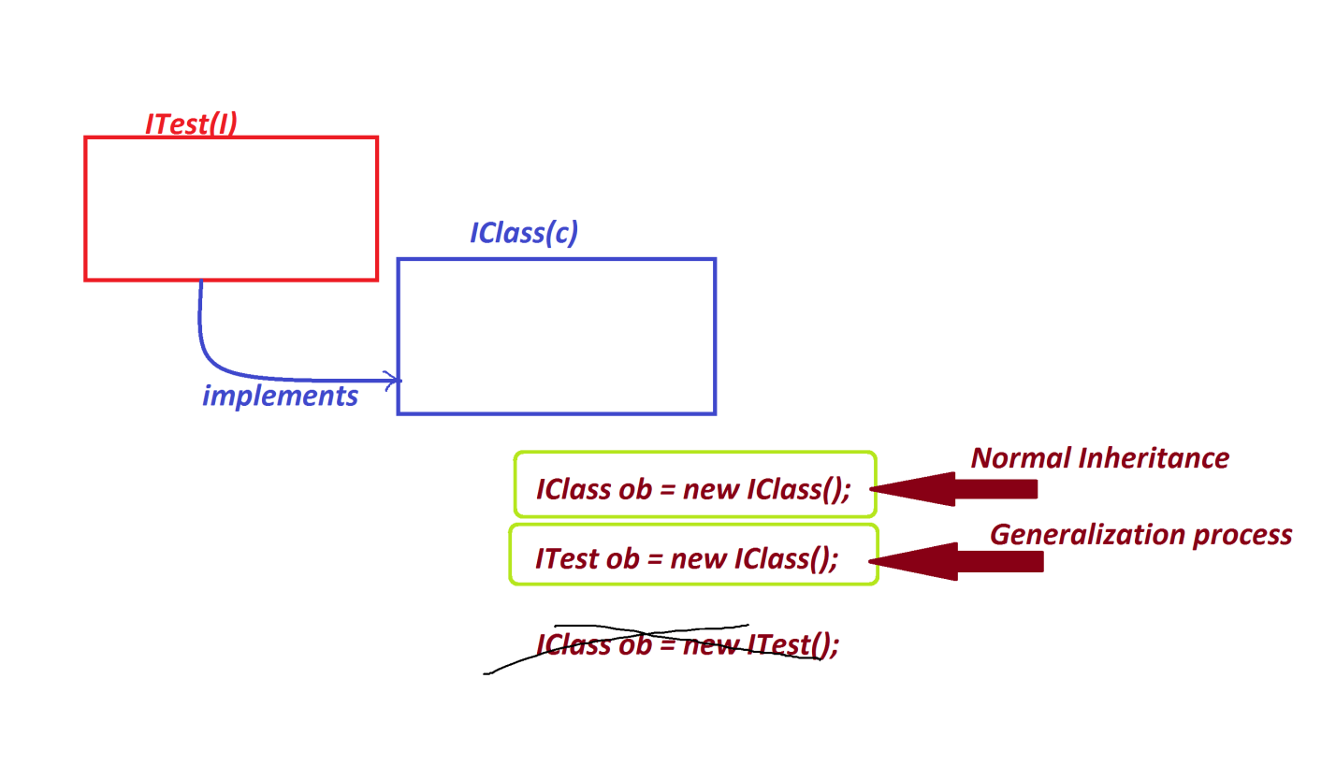

***===============================================================***

***faq:***

***define Comparable<T>?***

***=>Comparable<T> is an interface from java.lang package and which***

***support Sorting process.***

***structure of Comparable<T>:***

***public interface java.lang.Comparable<T>***

***{***

***public abstract int compareTo(T);***

***}***

***Note:***

***=>The objects which are generated from the class implemented from***

***java.lang.Comparable<T> interface will support sorting process.***

***==============================================================***